Cummins Programming

1. get ESN

2. look up ESN on <https://parts.cummins.com/>

3. type in ESN at top

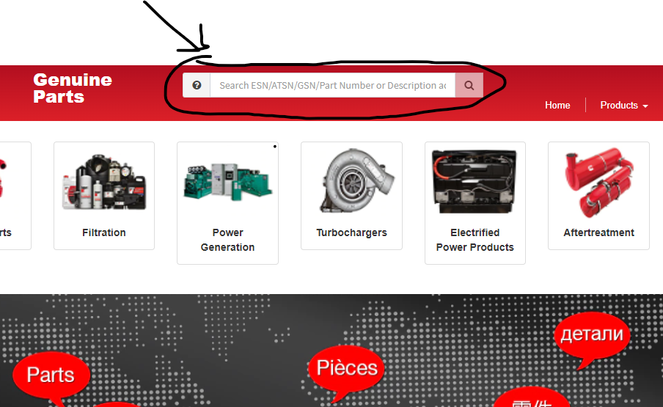

**4.** click on option view on left hand side of window

* IF ISX or ISB or any other IS? You MUST GET ECM CODE

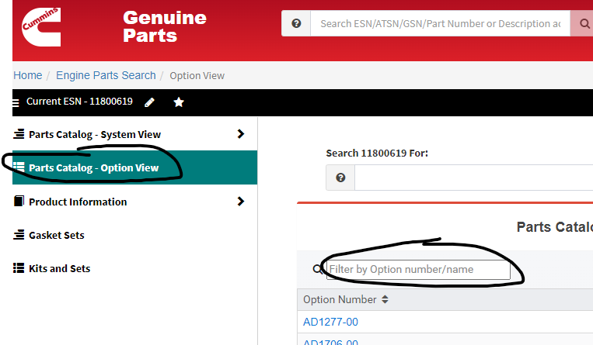

**ISX ECM CODE IS IN product information section**

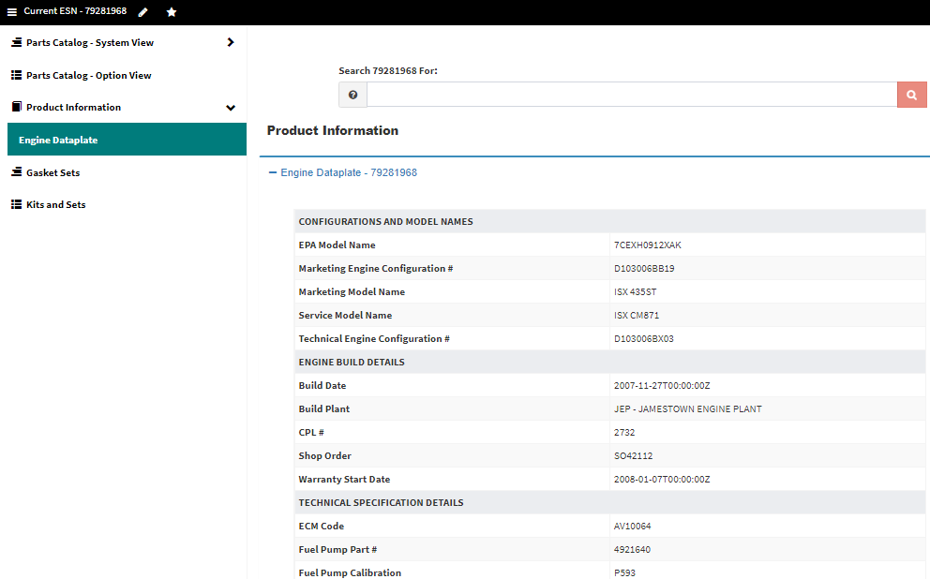

**5**. in the filter by Option Number/Name area you will search for **SC**

* SC – write down SC number
  + if it is blue click on it and write down CPL if available

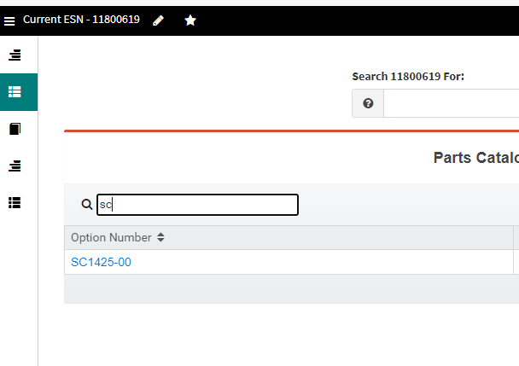

**6.** in the filter by Option Number/Name area you will search for **DO**

* DO – write down DO number

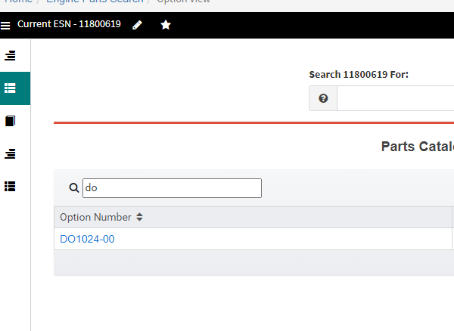

**7**. in the filter by Option Number/Name area you will search for **module**

* Module - look for engine control module **partnumber**
* click all blue options until you get a diagram with ECM on it

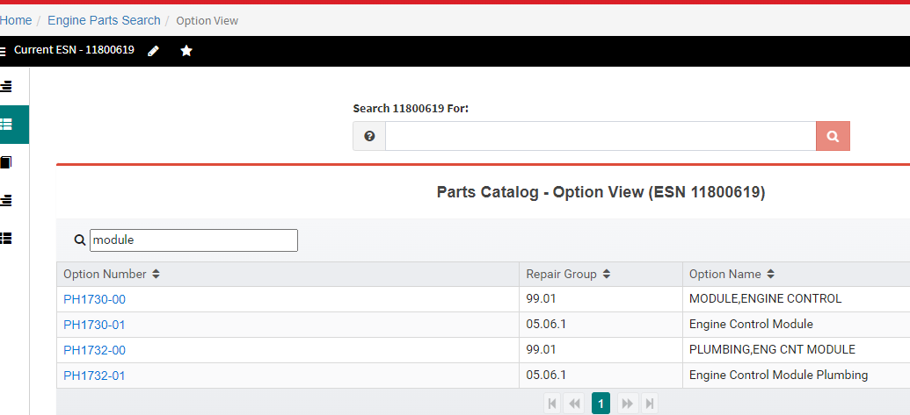

ECM diagram example:

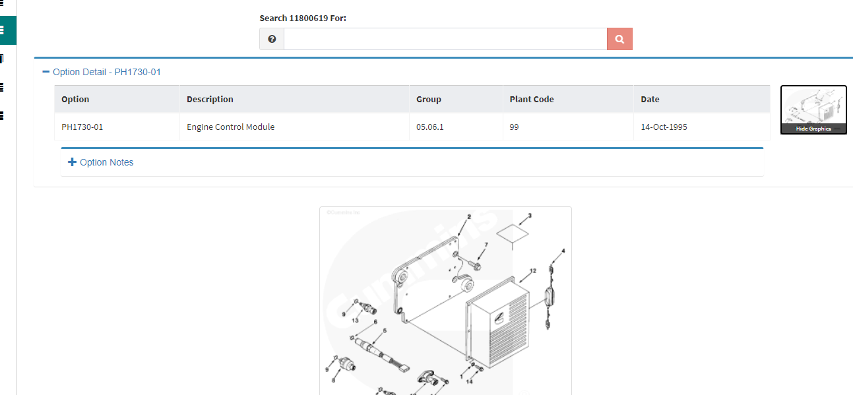

**8.** open cummins insite and connect to ECM

**connect to ecm button**

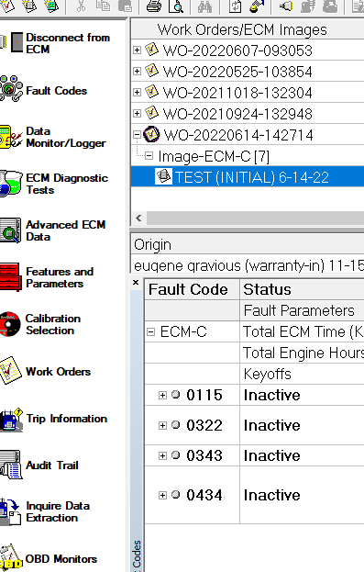

9. click calibration selection

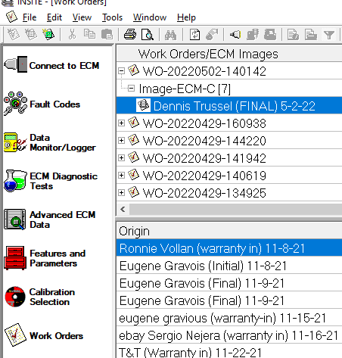

1. select engine type and ECM partnumber

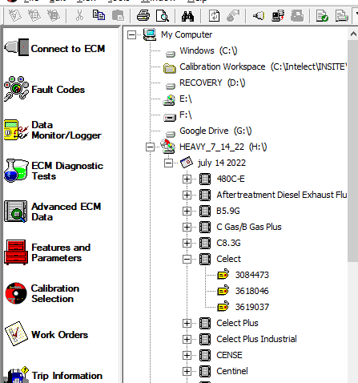

1. select calibration according to SC, CPL, DO and Horsepower using drop downs or **IF ISX USE THE ECM CODE**
   * if SC does not give you correct programming for the horsepower customer request
   * use CPL to filter out engines
     + CPL must match the one for engine if necessary use SC number to see what CPL is selected then keep filtering without the SC
   * then use Horsepower
     + use max governed speed
2. once you have filtered out calibrations send to ecm by right clicking on it and selecting transfer to ecm
   * only calibrations with green check mark are available so when multiple are left **only the green one can be sent**

